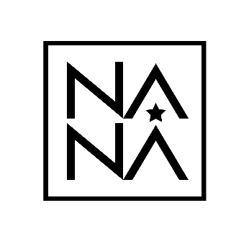
NANA Plastic Surgery Hospital
NANA Breast Academy (NBA)
Application Form

Desired month: [ ] April [ ] May
1. Personal Information
Name
Address
Phone Number
Fax Number
E-mail
Date of Birth
Place of Birth
Citizenship
First Language
Marital Status

2. Business Address
Hospital
Address
Phone Number
Fax Number
E-mail

For further Information:
Phone: +82 – 10 – 8671- 0601
Email: nanahospital.eng@gmail.com
Application Requirement:
Complete this form in writing or typing.
Please submit this form with:
Curriculum Vitae, 2 Recommendation letters, Photocopy of passport, and Certification of medical degrees

